Lab – Programming Language for Business Analytics


Submitted To:
Mam Mufeeza Manzoor

Submitted By:
Adeel Ahmad

Registration No.
FA24 – BBA – 086

COMSATS University Islamabad,
Lahore Campus
Department of Management Sciences

Task # 01:
Input:
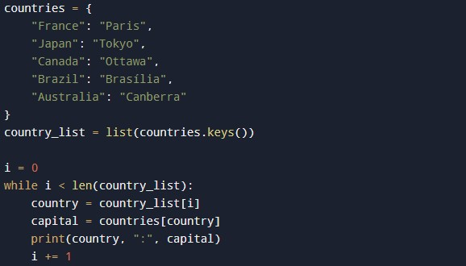
Output:
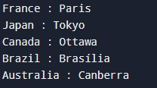

Task # 02:
Input:
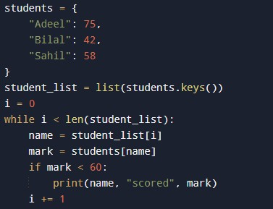

Output:
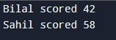

Task # 03:
Input:
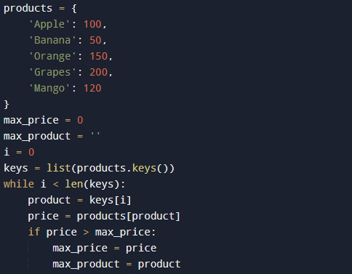
Output:

Task # 04:
Input:
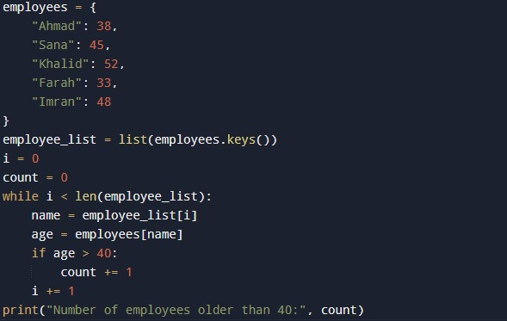
Output:

Task # 05:
Input:
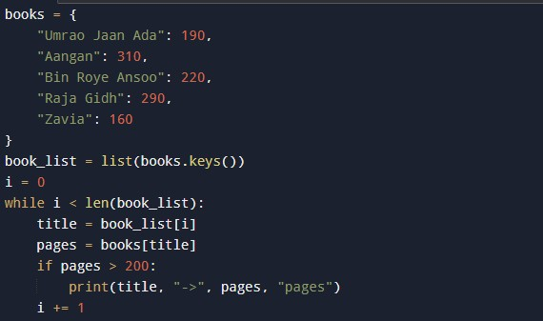
Output:
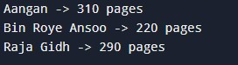

Task # 06:
Input:
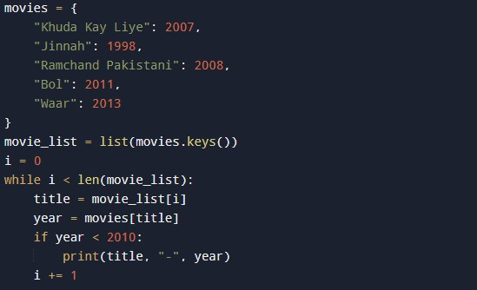
Output:


Task # 07:
Input:
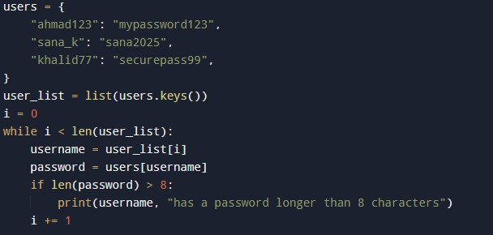
Output:
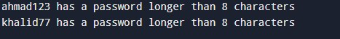

Task # 08:
Input:
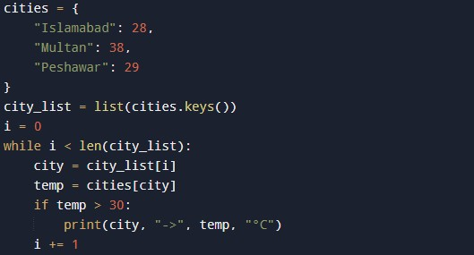
Output:
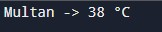

Task # 09:
Input:
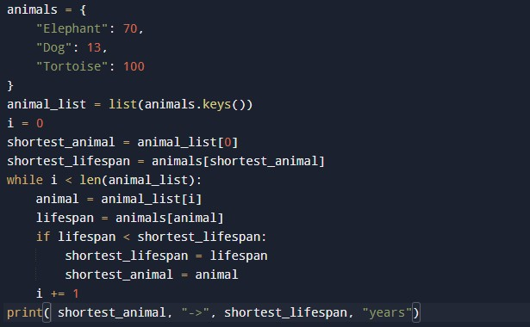

Output:


Task # 10:
Input:
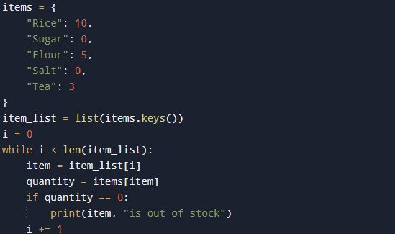
Output:
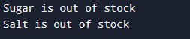

Task # 11:
Input:
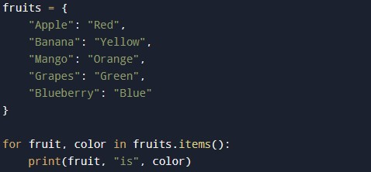
Output:
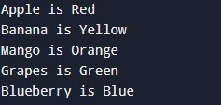

Task # 12:
Input:
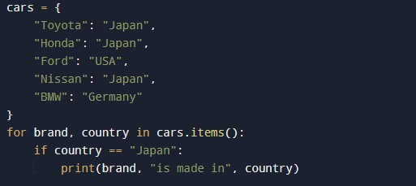

Output:
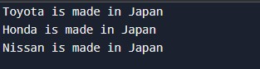

Task # 13:
Input:
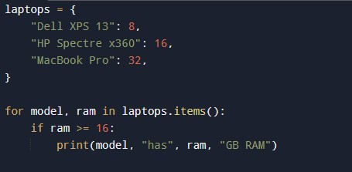
Output:
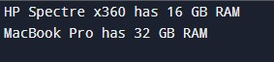

Task # 14:
Input:
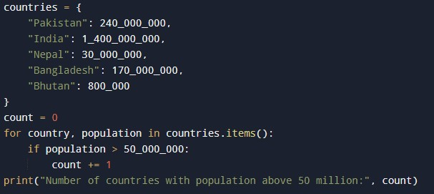
Output:

Task # 15:
Input:
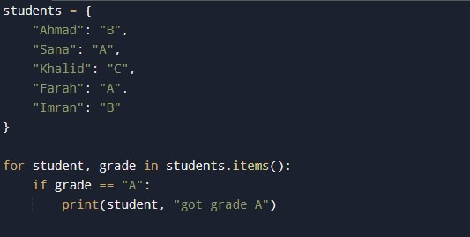

Output:


Task # 16:
Input:
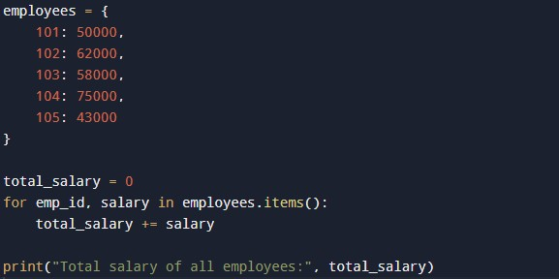
Output:

Task # 17:
Input:
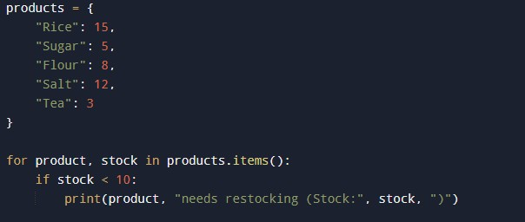
Output:
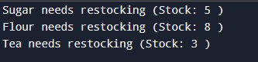

Task # 18:
Input:
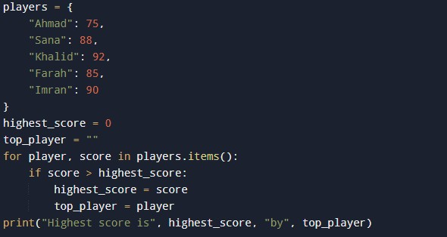
Output:


Task # 19:
Input:
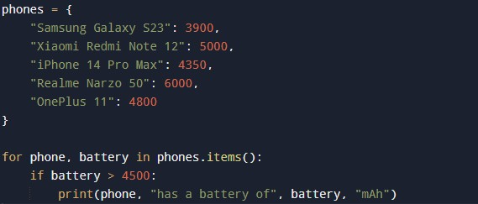
Output:
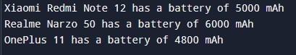

Task # 20:
Input:
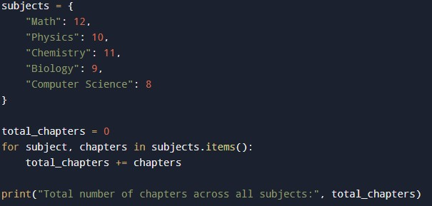
Output:

